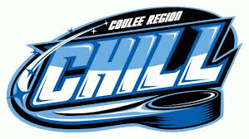

Fundraising for a Friend-

Coulee Region Chill Game



**Thursday March 30th** @ Green Island Ice Arena

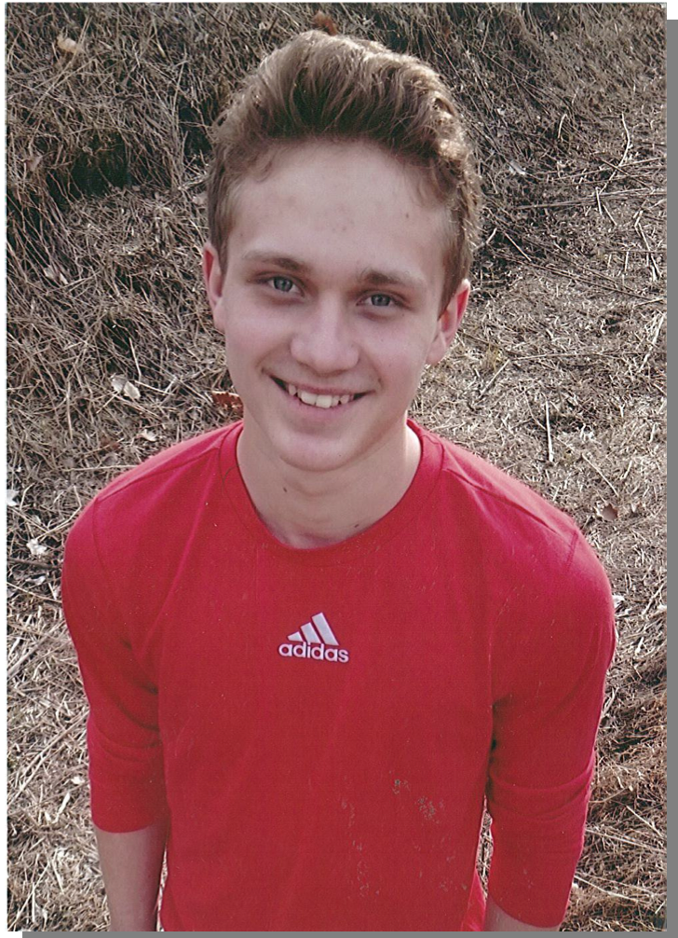

7:00 PM Myles Puck Drop

Coulee Chill vs. Janesville Jets

This year the Wishmakers are fundraising to grant Myles wish to go to Florida with his family this summer.

Fundraisers include

Chuck a Puck and Myles Miracle Minute

**To Donate to Myles Fund Online go to: site.wish.org/goto.uwlax**

Wishmakers on Campus La Crosse partners with Make-A-Wish Wisconsin to grant the wishes of children with life-threatening illnesses.

Green Island Ice Arena, 2312 7th St. S., La Crosse, WI, 54601

Students free with ID

Adults: $10.00