**West Salem Rod & Gun Club’s**

**13th ANNUAL**

**YOUTH DAY**

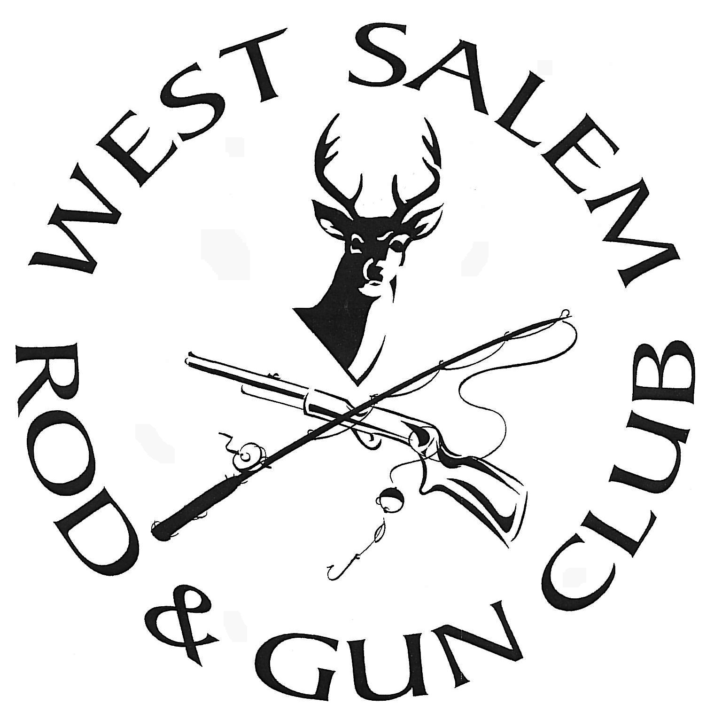

**How to Register:**

Pre-registration: West Salem Park & Rec. Dept. office until June 12th.  
On-site registrations: West Salem Rod & Gun day of the event.  
Fee**: FREE!**

Contact: Mark Ziegler at 608-786-1302 Visit us on Facebook

or at

[www.westsalemrodandgunclub.com](http://www.westsalemrodandgunclub.com)

**Saturday, June 17, 2017**

**1:00 p.m. – 3:00 p.m.**

**West Salem Rod & Gun Club Grounds**

**Directions:** Take Hwy. 16 to HWY 108; Turn right on McKinley Valley Rd; Turn right on Rod and Gun Club Rd. Follow signs.

**Hey Kids!**

**Take part in a variety of activities:**

**Casting, Archery, Tomahawk throw, Bean Bag Toss, DNR Warden Station, Tree Stand Safety, Game Calling and RMEF – SAFE (Shooting Access For Everyone)\***

This event is open to children up to age 13. RAIN OR SHINE!!

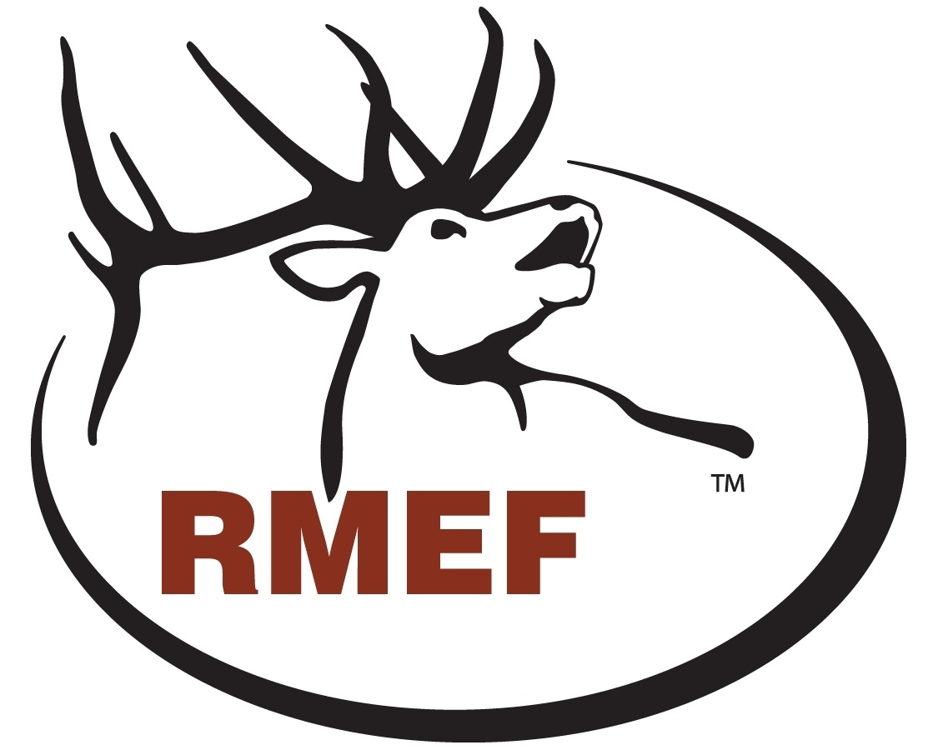

The **Rocky Mountain Elk Foundation** (RMEF) is sponsoring SAFE (Shooting Access For Everyone)

*SAFE will introduce young and novice shooters to safe and responsible firearm use, educate them about the hunter’s role in conservation and the North American Wildlife Conservation Model. Participants will have the opportunity to shoot an Air Rifle with help from RMEF SAFE mentors or experienced shooters.